Ecology Practice

1. In the region of the Rocky Mountains, imagine that one local variety of Ponderosa pine (Pinus ponderosa) predominantly occurs between 5,000-8,500 feet in elevation, where it can best tolerate temperatures and precipitation. If future climate change in this region causes the temperature to increase and rainfall to decrease, then which of the following changes might an ecologist predict about the variety's range?
A) that variety will occur at lower elevations
B) that variety will occur at higher elevations
C) that variety will occur at lower elevations and/or lower latitudes
D) that variety will occur at higher elevations and/or higher latitudes

2. When climbing a mountain, we can observe transitions in biological communities that are analogous to the changes ________.
A) in biomes at different latitudes
B) in a community through different seasons
C) in an ecosystem as it evolves over time
D) across the United States from east to west

3. The eight climographs show yearly temperature (line graph and left vertical axis) and precipitation (bar graph and right vertical axis) averages for each month for some locations on Earth.

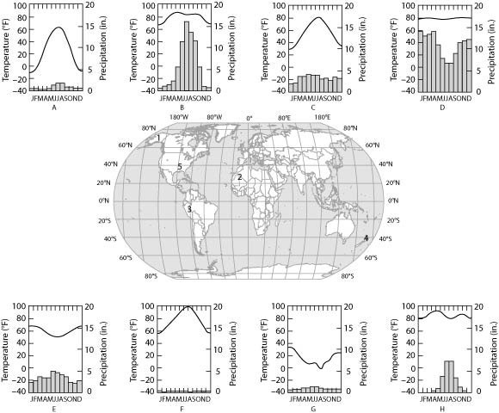

Which climograph shows the climate for location 2?
A) C
B) D
C) F
D) H

4. Use the following figure to answer the question below.

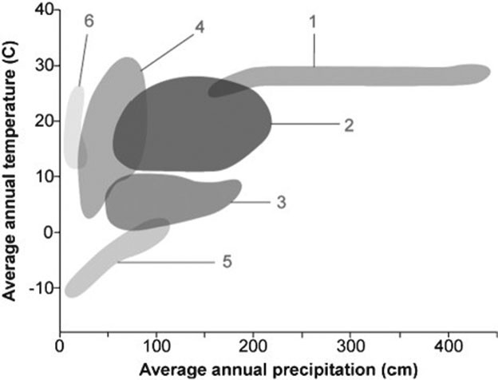

In the figure, which number would designate the biome with the highest variation in both annual precipitation and temperature?
A) 1
B) 2
C) 3
D) 4

5. If you are interested in observing a relatively simple community structure in a clear water lake, you would do well to choose diving into ________.
A) an oligotrophic lake
B) a eutrophic lake
C) a relatively shallow lake
D) a nutrient-rich lake

6. Which of the following examples demonstrate an ecological effect leading to an evolutionary effect?
A) When seeds are not plentiful, trees produce more seeds.
B) A few individuals with denser fur survive the coldest years of an ice age, and the offspring of the reproducing survivors of the ice age will likely have more dense fur.
C) Fish that swim the fastest in running water catch the most prey and more easily escape predation.
D) The insects that spend the most time exposed to sunlight have the most mutations from UV light, and thus evolve the fastest

7. Use the survivorship curves in the figure to answer the following question.

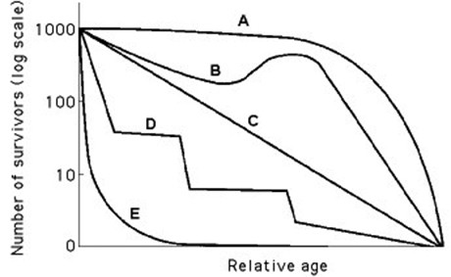

Which curve best describes survivorship in elephants?
A) A
B) B
C) C
D) E

8. Use the survivorship curves in the figure to answer the following question.

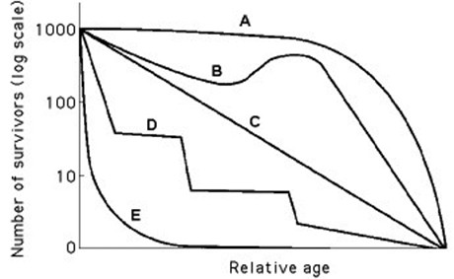

Which statement best explains survivorship curve B?
A) It is likely a species that provides little postnatal care, but lots of care for offspring during midlife as indicated by increased survivorship.
B) This curve is likely for a species that produces lots of offspring, only a few of which are expected to survive.
C) It is likely a species where no individuals in the cohort die when they are at 60-70% relative age.
D) Survivorship can only decrease; therefore, this curve could not happen in nature.

9. Imagine that you are managing a large game ranch. You know from historical accounts that a species of deer used to live there, but they have been extirpated. After doing some research to determine what might be an appropriately sized founding population, you reintroduce them. You then watch the population increase for several generations, and graph the number of individuals (vertical axis) against the number of generations (horizontal axis). With no natural predators impacting the population, the graph will likely appear as ________.
A) a diagonal line, getting higher with each generation
B) an "S" that ends with a vertical line
C) an upside-down "U"
D) a "J," increasing with each generation

10. Use the graph to answer the following question.

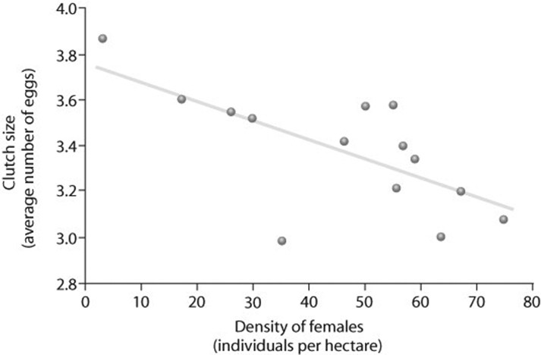

Based on the figure, which of the following statements correctly interprets the data?
A) Clutch size is always lowest at a density of about 35 females.
B) As female density increases, survivorship decreases.
C) Clutch size increases as female density increases.
D) Clutch size is inversely related to density.

11. Use the figure to answer the following question.

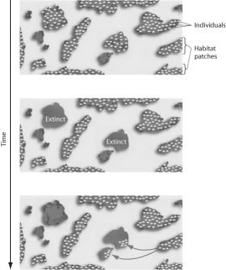

The figure represents the dynamics of ________.
A) metapopulations
B) extinction
C) emigration
D) both extinction and emigration

12. Use the figure to answer the following question.

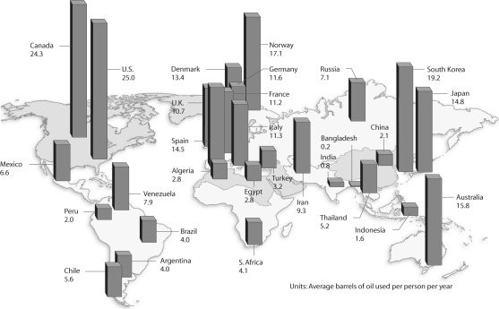

Based on the figure and given the populations of the following countries, which country uses the most oil overall?
A) United States (population = 320 million)
B) Canada (population = 36 million)
C) China (population = 1.33 billion)
D) Russia (population = 144 million)

13. If two species are close competitors, and one species is experimentally removed from the community, the remaining species would be expected to ________.
A) change its fundamental niche
B) decline in abundance
C) become the target of specialized parasites
D) expand its realized niche

14. In some circumstances, grasses that initially lose tissues from being consumed by animals such as elk or cattle regrow more than they would have otherwise, and benefit from the moderate levels of grazing. Which of the following terms would best describe such a plant-herbivore interaction?
A) mutualism
B) commensalism
C) parasitism
D) predation

15. Approximately how many kilograms (kg) of carnivore (secondary consumer) biomass can be supported by a field plot containing 1000 kg of plant material?
A) 1000
B) 100
C) 10
D) 1

16. Which of the following could qualify as a top-down control on a grassland community?
A) limitation of plant biomass by rainfall amount
B) influence of temperature on competition among plants
C) influence of soil nutrients on the abundance of grasses versus wildflowers
D) effect of grazing intensity by bison on plant species diversity

17. Which of the following is a correct statement about MacArthur and Wilson's island equilibrium model?
A) As the number of species on an island increases, the emigration rate decreases.
B) Competitive exclusion is less likely on an island that has large numbers of species.
C) Small islands receive few new immigrant species.
D) Islands closer to the mainland have higher extinction rates.

18. In terms of community ecology, why are pathogens often more virulent now than in the past?
A) More new pathogens have recently evolved.
B) Host organisms have become more susceptible because of weakened immune systems.
C) Human activities are transporting pathogens into new habitats (or communities) at an unprecedented rate.
D) Medicines for treating pathogenic disease are in short supply.

19. Which of the following organisms is correctly paired with its trophic level?
A) cyanobacterium—primary consumer
B) grasshopper—secondary consumer
C) phytoplankton—primary producer
D) fungus—primary consumer

20. Use the following figure to answer the question.

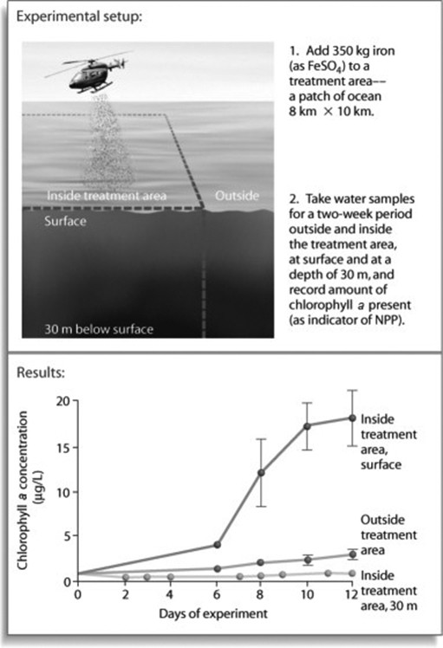

After looking at the results in the figure, what can be concluded about productivity in the experimental ecosystem?
A) Productivity is higher at depth than at the surface, but only initially.
B) Productivity is higher at the surface than at depth; however, an additional experiment could further test the effect of depth by introducing FeSO4 at 30 m deep and measuring the chlorophyll a response.
C) Productivity is higher at the surface than at depth, and would be predicted to increase sharply after day 12.
D) Productivity at a depth of 30 m is low only because of a lack of sunlight, not a lack of iron sulfate.

21. Why is it that satellites, using wavelength reflectance technology, detect variable levels of productivity across Earth's oceans, rather than an increase toward the equator?
A) Temperatures at the equator often exceed those which are optimal for primary production.
B) Light at the equator is too constant and direct.
C) NPP in Earth's open oceans could differ due to variability in depth, the presence of coral reefs, or by ocean currents.
D) Satellites detect differences by measuring the amount of water vapor emitted by transpiring producers, and this is a variable measurement in the oceans.

22. Consider the food chain of grass → grasshopper → mouse → snake → hawk. About how much of the chemical energy fixed by photosynthesis of the grass (100 percent) is available to the hawk?
A) 0.01%
B) 0.1%
C) 1%
D) 10%

23. Use the following figure to answer the question.

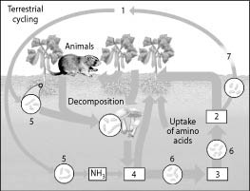

On the diagram of the nitrogen cycle, which number represents nitrite (NO2)?
A) 1
B) 2
C) 3
D) 4

24. Acid precipitation lowered the pH of soil in a terrestrial ecosystem that supported a diverse community of plants and animals. The decrease in pH eliminated all nitrogen-fixing bacteria populations in the area. Which prediction most accurately reflects the impact this will have on the community?
A) Since phosphorus can replace nitrogen as an essential nutrient, the impact will be minimal.
B) Plants can obtain the nitrogen necessary for growth from the atmosphere, but bacterial communities will be negatively impacted.
C) Primary producers will suffer from nitrogen deficiency and the entire community will experience a decrease in carrying capacity.
D) The decrease in pH actually increases the availability of soil nutrients, so other nutrients that were less available cause an increase in primary production and an increase in biomass at other trophic levels.

25. Which of the following observations provides the best evidence of a biodiversity crisis?
A) the incursion of a non-native species
B) increasing pollution levels
C) high rate of extinction
D) climate change

26. Researchers have been studying a rare population of 87 voles in an isolated area. Ten voles from a larger population were added to this isolated population. Besides having ten additional animals, what benefits are there to importing individuals?
A) There is no benefit other than increasing the overall population size.
B) Additional voles will strengthen competition and increase the survival of the fittest.
C) Additional animals would increase beneficial genetic drift.
D) Additional voles from a distant population will likely increase genetic diversity and reduce inbreeding.

27. The primary difference between the small-population approach and the declining-population approach to biodiversity recovery is that ________.
A) small-population approach is interested in bolstering the genetic diversity of a threatened population rather than the environmental factors that caused the population's decline
B) small-population approach applies for conservation biologists when population numbers fall below 500
C) declining-population approach would likely involve bringing together individuals from scattered small populations to interbreed in order to promote genetic diversity
D) small-population approach would investigate and eliminate all of the human impacts on the habitat of the species being studied for recovery

28. Which of the following is a generally accurate statement about the current research regarding forest fragmentation?
A) Fragmented forests promote biodiversity because they result in the combination of forest-edge species and forest-interior species.
B) In fragmented forests, the number of forested-adapted species tend to decline and the number of edge species tend to increase.
C) Fragmented forests are the goal of conservation biologists who design wildlife reserves.
D) The disturbance of timber extraction causes the species diversity to increase because of the new habitats created.

29. Your friend is wary of environmentalists' claims that global warming could lead to major biological change on Earth. Which of the following statements can you use in response to your friend's suspicions?
A) We know that atmospheric carbon dioxide has decreased over the past 150 years.
B) Through measurements and observations, we know that carbon dioxide levels and temperature fluctuations are indirectly correlated.
C) Global warming could have minor effects on agriculture in the United States.
D) Scientist have evidence that climate change has already altered primary production, as well as ecosystem services.

30. Which of the following statements about protected areas that have been established to preserve biodiversity is correct?
A) About 25 percent of Earth's land area is now protected.
B) Developing nations have a larger ecological footprint than developed nations, thus protected areas should be primarily established in developing nations.
C) Management of a protected area should be coordinated with management of the land surrounding the area.
D) It is only important to protect land within biodiversity hot spots.

